Assignment 2: Max Warriner (126104460)

  - Find in R Script

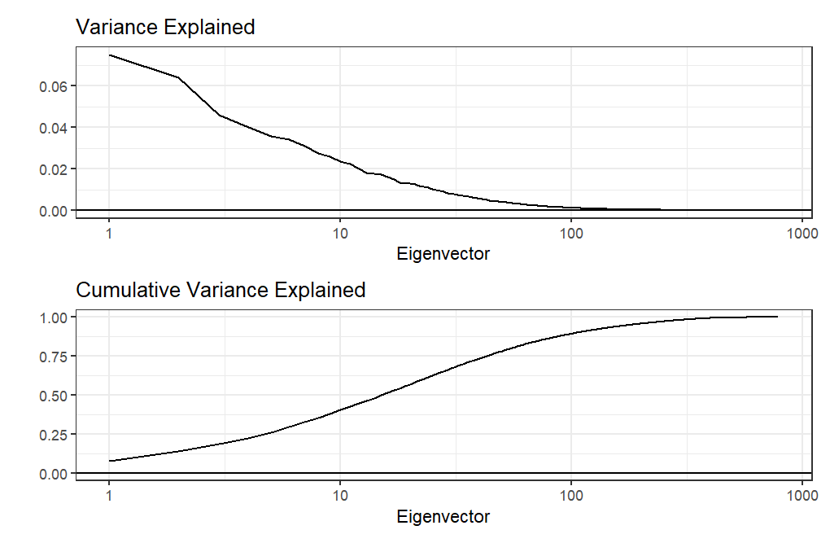
Figure 1. Eigenvalue Variance Analysis
346 eigenvectors are needed to explain at least 99% of the variance in the data.

  - Find data structure in R Script
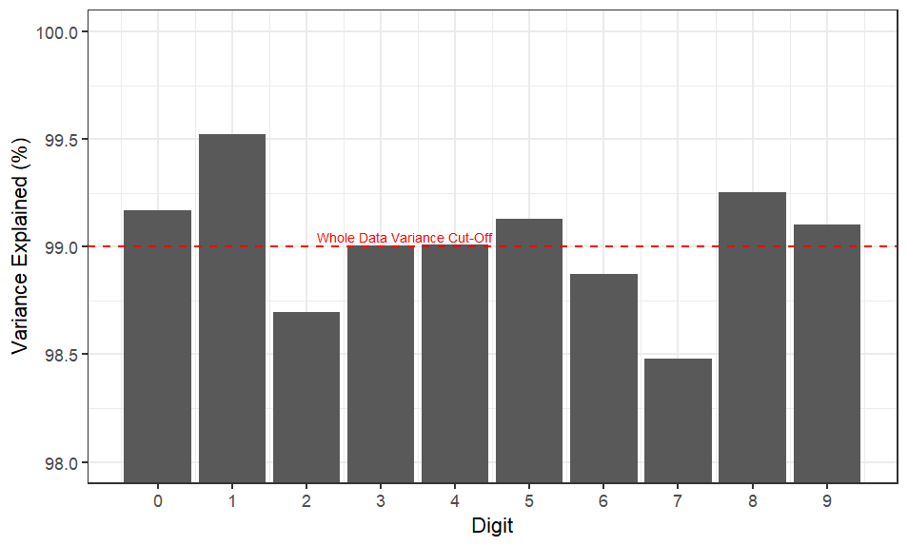
Figure 2. Digit Variance Analysis

  - Find in R Script
  - (also c.)
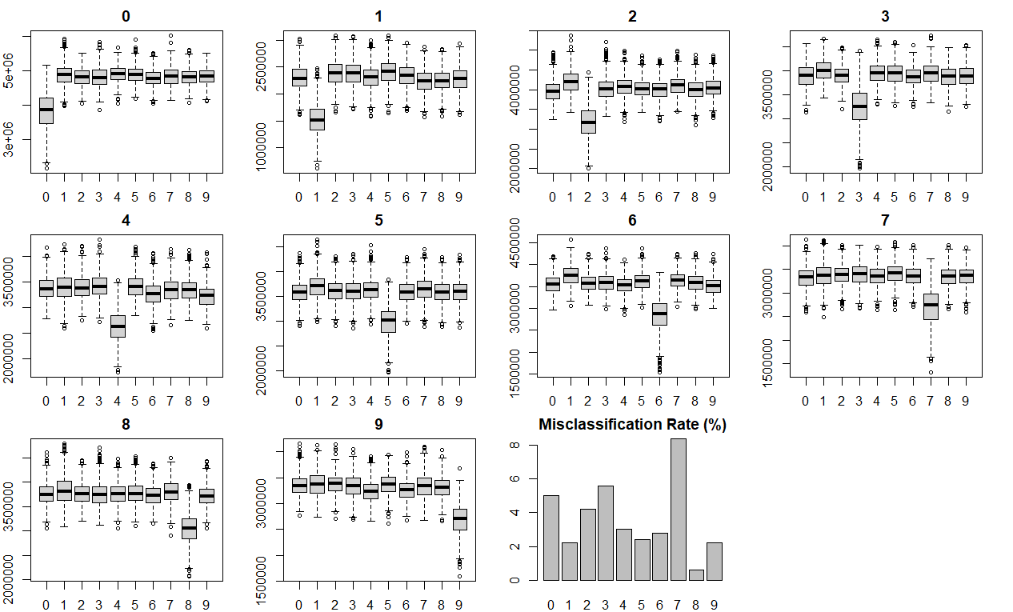
Figure 3. Residual Sum of Squares by Digit Analysis

  - Number of Stars Removed in Each Class
Star Type | Outliers Removed
BYDra | 217
CEP | 0
CEPII | 0
DSCT | 0
EA | 45
EW | 75
Mira | 2211
RR | 1
RRc | 0
RSCVN | 134
SR | 5134

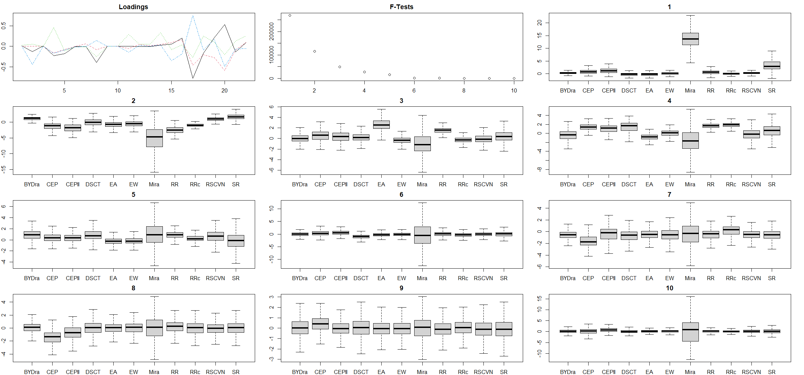

Figure 4. LDA Analysis of Stars Data

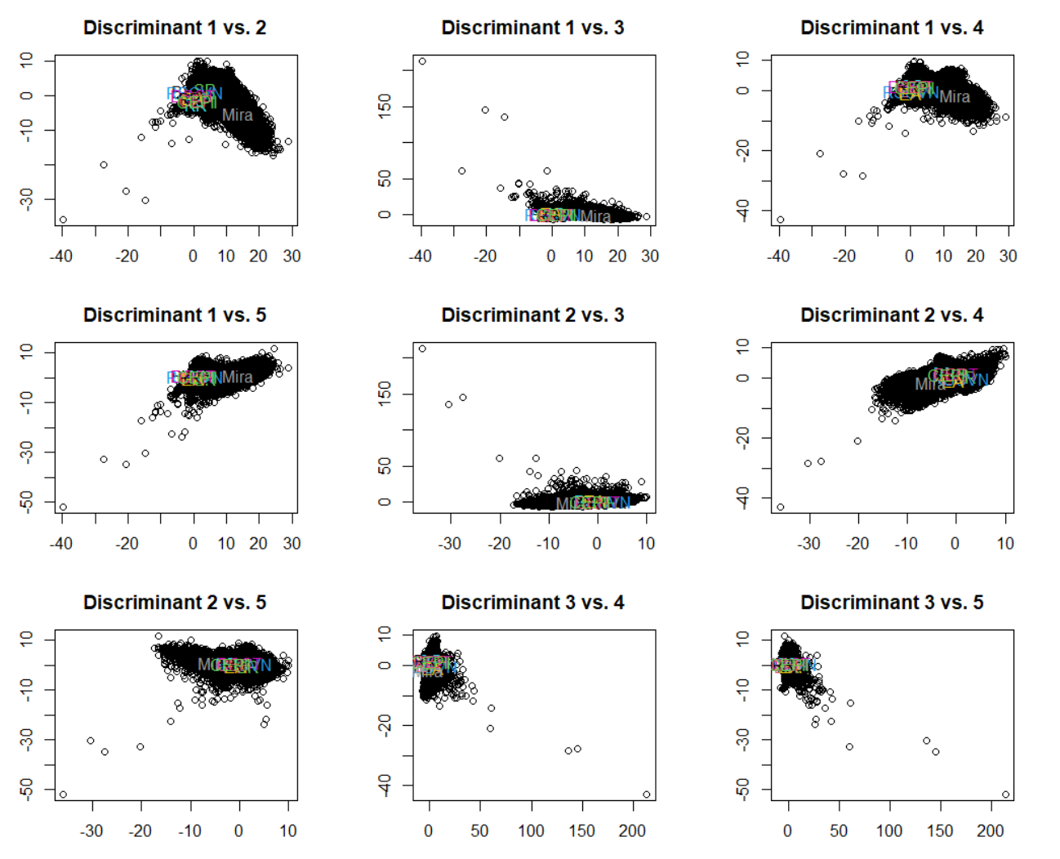
Figure 5. Pairwise Discriminant Analysis of Stars Data

    - Linear Discriminant Analysis Misclassification Rate Analysis
Star Type | Misclassification Rate
BYDra | 44.1%
CEP | 85.0%
CEPII | 98.9%
DSCT | 75.5%
EA | 23.1%
EW | 6.4%
Mira | 9.1%
RR | 17.9%
RRc | 88.7%
RSCVN | 87.7%
SR | 26.9%

Quadratic Discriminant Analysis Misclassification Rate Analysis
Star Type | Misclassification Rate
BYDra | 27.0%
CEP | 30.9%
CEPII | 59.2%
DSCT | 5.2%
EA | 18.0%
EW | 19.5%
Mira | 0.5%
RR | 4.0%
RRc | 8.4%
RSCVN | 73.9%
SR | 7.9%

    - Overall Misclassification Rates
Linear Discriminant Analysis Misclassification Rate = 26.8%
Quadratic Discriminant Analysis Misclassification Rate = 22.9%

We see that overall, the quadratic discriminant analysis performs better than the linear discriminant analysis, showing evidence for different covariance structures between different star types that is useful for classification.

A simple correlation analysis shows that sample size has a strong negative correlation with misclassification rate in the LDA (r = -0.49), but less so in the QDA (r = -0.01). This makes sense with the poorer performance in the LDA, where the model tends to overestimate the larger classes as opposed to the more sensitive and precise QDA analysis.

